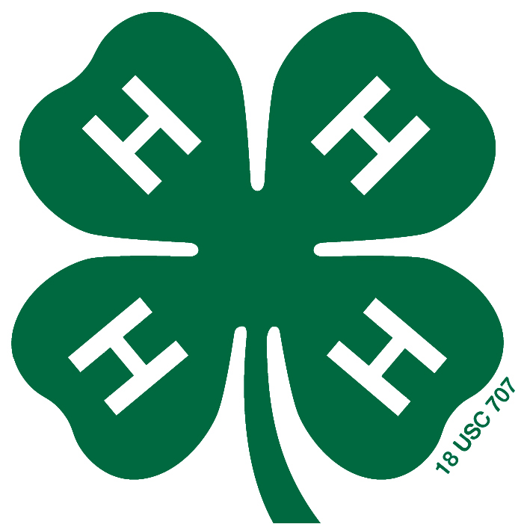
North Carolina
4-H Achievement Plan

NAME _______________________ DATE OF BIRTH __________

Address _______________________________________________________

_______________________________________ ZIP ____________

Name of Club ________________________ Years in Club _______________

Parent/Guardian Name ___________________________________________

Do you set goals for yourself or do others set them for you? How do you feel when you accomplish something? Does what you accomplish make a difference to you? How can you plan and work to do a better job of meeting your goals? When you reach a goal, and feel some satisfaction in reaching that goal, does this help you set new goals? What if you are not quite satisfied with your accomplishments? How can you get the most out of 4-H and receive satisfaction for your goals?

The 4-H Achievement Plan will help you with these things. It will help in:

- Setting your goals and making plans to reach them.
- Enriching your 4-H program as you grow.
- Evaluating your own efforts and accomplishments and by taking a look with your leader as to how well you have met your goals.
- Reaching more of your goals.
- Setting new goals that will help you grow and develop your skills and personality.

To be successful your plan will require loyalty to your 4-H club, your county, state, nation, and world. Service to others is very important. Creativity, responsibility, and leadership will be required. The satisfaction you feel for your job well done will make it all worthwhile.

Planning – To achieve your highest goals, plan your 4-H participation and set your goals at the start of your year or immediately after achieving a lower level. Use this achievement form to talk with your family and 4-H Leaders. Ask their advice in helping to set your goals and to help you accomplish them.

Directions:
- Check the suggestions in the “Planned” column that you plan to accomplish.
- Fill out the “Date Accomplished” column when you complete a requirement.
- Check the highest award listed below for which you are applying.
- Turn this in to your 4-H leader when you meet the minimum requirements for a Level.
- Only one level may be reached each year in 4-H
- You may begin the Achievement Plan at any time in your 4-H career. You must be 9 years old to begin the Green Clover Award. It may take more than 1 year to finish a level.

4-H’ers who strive and excel in improving themselves, their clubs, and their communities shall be given appropriate awards as follows:

___ Cloverbud 5-7 Achievement Award
___ Green Clover Achievement Award
___ Bronze Achievement Award
___ Silver Achievement Award
___ Gold Achievement Award
___ Achievement Medal

The Certificates may be obtained from the State 4-H office for the Green, Bronze, Silver and Gold Achievement Awards. The Achievement Medal can be ordered from National 4-H Supply by the county.

5-6-Year-Old Cloverbud Achievement Award
To be eligible you must do Requirements 1- 3 and 2 optional activities.

Date
Planned Completed

1. Attend at least 3/4th of the scheduled 4-H meetings.

2. Have a planning meeting with your 4-H Leader.

3. Learn and lead the 4-H Pledge.

Date
Planned Completed Optional Activities

4. With your family’s help, complete a Curriculum Book.
Book ___________________________

5. Learn and lead the 4-H motto.

6. Make a collage or draw a picture to show what you’ve learned in 4-H and bring to club meeting.

7. “Show and Tell” about something you’ve learned in 4-H with your family.

Upon completing requirements for this Level, sign your name below, have your parent/guardian sign, and give the total achievement plan to your club or group leader.

Your Signature _________________________________________ Date ______________

Parent or Guardian Signature ________________________________________________

I have evaluated and approved this application for the Cloverbud Ruby Achievement Award.

4-H Leader’s Signature _________________________________ Date ________________

7-Year-Old Cloverbud Achievement Award
To be eligible you must do Requirements 1- 4 and 3 optional activities.

Date
Planned Completed

1. Attend at least 3/4th of the scheduled 4-H meetings.

2. Participate in at least 1 county 4-H event. Event _______

3. Learn and lead the 4-H Pledge.

4. Have a planning meeting with your 4-H Leader.

Date
Planned Completed Optional Activities

5. With your family’s help, complete a Curriculum Book Book_______________________

6. Lead the American Pledge at a 4-H meeting.

7. Create a craft item that shows what you like about 4-H and bring to a club meeting.

8. “Show and Tell” about something you’ve learned in 4-H with your family.

9. Participate in one community service project. List _______

Upon completing requirements for this Level, sign your name below, have your parent/guardian sign, and give the total achievement plan to your club or group leader.

Your Signature _________________________________________ Date ______________

Parent or Guardian Signature ________________________________________________

I have evaluated and approved this application for the Cloverbud Sapphire Achievement Award.
4-H Leader’s Signature _________________________________ Date ________________

Green Clover Achievement Award (For ages 8-18)
To be eligible you must do Requirements 1- 4 and 4 optional activities.

Date
Planned Completed

1. Attend at least 3/4th of the scheduled 4-H meetings

2. Complete and turn in at least one project record book to your 4-H leader. Project _________________

3. Participate in at least 1 county 4-H event. Event _______

4. Have a planning meeting with your 4-H Leader.
Planned Completed Optional Activities

5. Have a parent or other adult to attend at least two club or group meetings.

6. Learn what county and 4-H district you are in: ______________________________________.

7. Exhibit at least one 4-H project. What exhibited? ________________ Where? _______________

8. Give a talk about your 4-H project before a group. Topic: _____________________ Where? ____________

9. Participate in one community service project. List _______

10. Attend 4-H District Activity Day.

Upon completing requirements for this Level, sign your name below, have your parent/guardian sign, and give the total achievement plan to your club or group leader.

Your Signature _________________________________________ Date ______________

Parent or Guardian Signature ________________________________________________

I have evaluated and approved this application for the Green Clover Achievement Award.

4-H Leader’s Signature _________________________________ Date ________________
Bronze Achievement Award (For ages 8-18)
You must have already received the Green Clover Achievement Award.
To be eligible you must do Requirements 1- 5 and 5 optional activities.

Date
Planned Completed

1. Attend at least 3/4th of the scheduled 4-H meetings

2. Complete and turn in at least two project record books to 4-H Club leader. Books ____________________

3. Give Presentation or talk at 4-H meeting. Topic: ________________________

4. Participate in at least one community service project. Project: __________________________

5. Have a planning meeting with your 4-H Leader.

Planned Completed Optional Activities

6. Work on a committee in your club or county. List: _____________________________________

7. Attend County Achievement Program.

8. Participate in a county, district, or state contest (speaking, talent, judging, shows). Type: ________________

9. Participate in another countywide activity. List _________

____ ____ 10. Be on a program at a local club meeting (ex: Lions, Ruritans). Date ____________________

11. Self Determined goal; approved by 4-H Club Leader. Explain________________________

12. Participate in North Carolina 4-H Congress.

13. Exhibit at least one 4-H project. What exhibited? ________________ Where? _______________

Upon completing requirements for this Level, sign your name below, have your parent/guardian sign, and give the total achievement plan to your club or group leader.

Your Signature _________________________________________ Date ______________

Parent or Guardian Signature ________________________________________________

I have evaluated and approved this application for the Bronze Achievement Award.

4-H Leader’s Signature _________________________________ Date ________________

Silver Achievement Award (For ages 8-18)
You must have already received the Green Clover and Bronze Achievement Awards.

To be eligible you must do Requirements 1- 7 and 8 optional activities.

Date
Planned Completed

1. Attend at least 3/4th of the scheduled 4-H meetings

2. Complete and turn in at least three project record books to 4-H Club leader. Books ____________________

- Give Presentation or talk at 4-H meeting. Topic: ________________________

4. Participate in at least two community service projects. Projects: __________________________

5. Work on a committee in your club or county. List: _____________________________________

6. Attend at least one County Council Meeting. Date ______

7. Have a planning meeting with your 4-H Leader.

Planned Completed Optional Activities

8. Attend County Achievement Program.

9. Assist with County 4-H Camps if possible. List: ________

10. Participate in a county 4-H Entertains. Act: __________

11. Give a Presentation at County 4-H Activity Day. List _________

12. Participate in a District Retreat. Date: ______________

____ ____ 13. Give a 4-H talk or presentation at a local club meeting (ex: Lions, Ruritans). Date ____________________
____ ____ 14. Give a speech at 4-H Meeting/Activity Contest. Title: ______________

____ ____ 15. Serve as a Club Officer. Office: ________________

16. Self Determined goal; approved by 4-H Club Leader. Explain________________________

17. Participate in North Carolina 4-H Congress.

18. Exhibit at least one 4-H project. What exhibited? ________________ Where? _______________.

____ ____ 19. Participate in district or state 4-H Activity. What: _______

____ ____ 20. Recruit one young person for your club. Name ________

Upon completing requirements for this Level, sign your name below, have your parent/guardian sign, and give the total achievement plan to your club or group leader.

Your Signature _________________________________________ Date ______________

Parent or Guardian Signature ________________________________________________

I have evaluated and approved this application for the Silver Achievement Award.

4-H Leader’s Signature _________________________________ Date ________________

Gold Achievement Award (For ages 8-18)
You must have already received the Green Clover, Bronze and Silver Achievement Awards.

To be eligible you must do Requirements 1- 7 and 10 optional activities.

Date
Planned Completed

1. Serve as Junior/Teen Leader in County Event or Activity or at your club. List: _____________________

2. Complete and turn in at least three project record books or one Cumulative Record to 4-H Club leader. Books: ____________________

- Give Presentation or talk at 4-H meeting or other group. Topic: ________________________

4. Participate in at least two community service projects. Projects: __________________________

5. Serve as a chairman of a committee in your club or county. List: _____________________________________

6. Attend at least one County Council Meeting. Date ______

7. Have a planning meeting with your 4-H Leader.

Planned Completed Optional Activities

8. Serve as a Leader in Training (LIT) at a State 4-H Camp.

9. Volunteer at a community agency. # Hours: __________

10. Participate in a county 4-H Entertains. Act: __________

11. Publish a news article related to 4-H.

12. Participate in District Retreat. Date: ______________

____ ____ 13. Give a 4-H talk or presentation at a local club meeting (ex: Lions, Ruritans). Date ____________________
____ ____ 14. Give a speech at 4-H Meeting/Activity Contest. Title: ______________

____ ____ 15. Serve as a County Council Officer and attend 2/3 of the meetings. Office: ________________

16. Self Determined goal; approved by 4-H Club Leader. Explain________________________

17. Plan and carry out an individual community service project. Explain: _________________________

18. Exhibit at least one 4-H project. What exhibited? ________________ Where? _______________.

____ ____ 19. Attend NC Citizenship Focus.

____ ____ 20. Assist other 4-H’ers with a project. List: ______________

____ ____ 21. Participate in the Application, Resume & Interview process.

____ ____ 22. Attended National 4-H Congress. Date: ____________

____ ____ 23. Attended National 4-H Conference. Date: __________

____ ____ 24. Participate as a delegate in a 4-H Exchange Trip with another county or state or serve as a host to a 4-H delegate from another county or state.

____ ____ 25. Assist in organizing a new 4-H club. Explain your part in planning for and helping with the organization of the club. ________________________________

Upon completing requirements for this Level, sign your name below, have your parent/guardian sign, and give the total achievement plan to your club or group leader.

Your Signature _________________________________________ Date ______________

Parent or Guardian Signature ________________________________________________

I have evaluated and approved this application for the Gold Achievement Award.

4-H Leader’s Signature _________________________________ Date ________________
Achievement Medal (For ages 13-18)
You must have already received the Green Clover, Bronze, Silver, and Gold Achievement Awards. The Achievement Medal is a special award for outstanding older 4-H’ers.

To be eligible you must:

Date
Planned Completed

1. Meet Guidelines 1-7 for the Gold Achievement Award (must be repeated).

____ ____ 2. Complete 20 optional activities. These can be selected
From activities in the silver or gold achievement
Awards. Items # 22 & 23 may not be repeated.
The same type of events may not be repeated twice.
(Example: Silver #10 and Gold #10)
Required activities:

Date

Planned Completed

1. Serve as Junior/Teen Leader in County Event or Activity or at your club. List: _____________________

2. Complete and turn in at least three project record books or one Cumulative Record to 4-H Club leader. Books: ____________________

- Give Presentation or talk at 4-H meeting or other group. Topic: ________________________

4. Participate in at least two community service projects. Projects: __________________________

5. Serve as a chairman of a committee in your club or county. List: _____________________________________

6. Attend at least one County Council Meeting. Date ______

7. Have a planning meeting with your 4-H Leader.

Silver Optional Activities Gold Optional Activities

Date Date
Planned Completed Activity Planned Completed Activity

8. ___________ 8. ____________

9. ___________ ____ ____ 9. ____________

10. ___________ ____ ____ 10. ___________

11. ___________ ____ ____ 11. ___________

12. ___________ ____ ____ 12. ___________

13. ___________ ____ ____ 13. ___________

14. ___________ ____ ____ 14. ___________

15. ___________ ____ ____ 15. ___________

16. ___________ ____ ____ 16. ___________

17. ___________ ____ ____ 17. ___________

18. ___________ ____ ____ 18. ___________

19. ___________ ____ ____ 19. ___________

20. ___________ ____ ____ 20. ___________

____ ____ 21. ___________

. ____ ____ 22. ___________

____ ____ 23. ___________

. ____ ____ 24. ___________

____ ____ 25. ___________

Upon completing requirements for this Level, sign your name below, have your parent/guardian sign, and give the total achievement plan to your club or group leader.

Your Signature _________________________________________ Date ______________

Parent or Guardian Signature ________________________________________________

I have evaluated and approved this application for the Achievement Medal.

4-H Leader’s Signature _________________________________ Date ________________

Agent’s Signature _____________________________________ Date ________________

